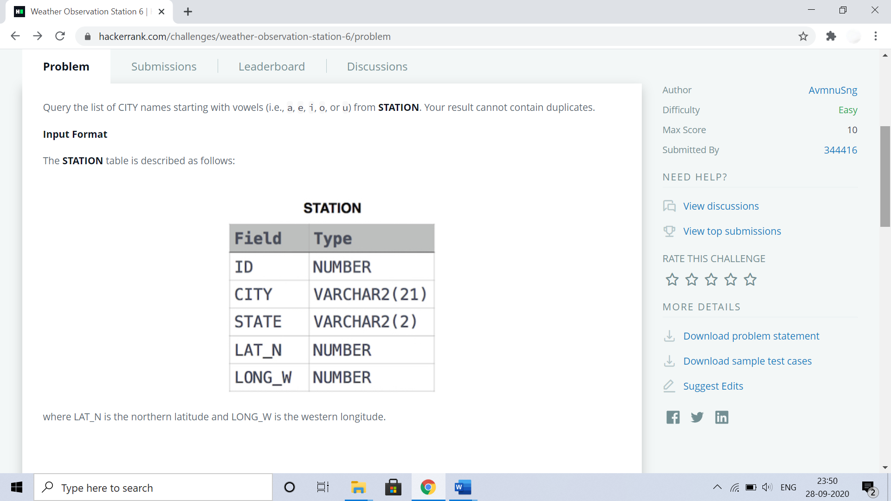

**Query**

**SELECT DISTINCT city FROM station WHERE city REGEXP "^[aeiou].*";**